Game Release Environment
It is to be expected that the game will be released in November 2020. Although we cannot be 100% certain on the environment that the game will be released in at this given time, we can expect to be majorly competing with the following upcoming indie games:

Wayward Strand

The Pathless

Sable
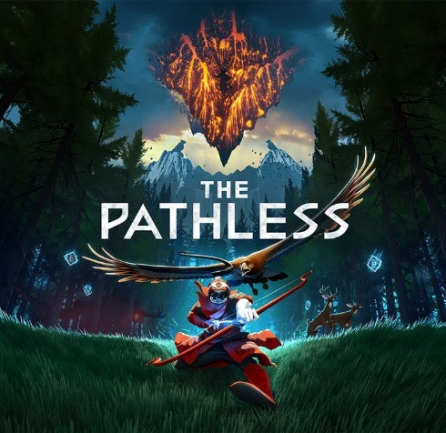
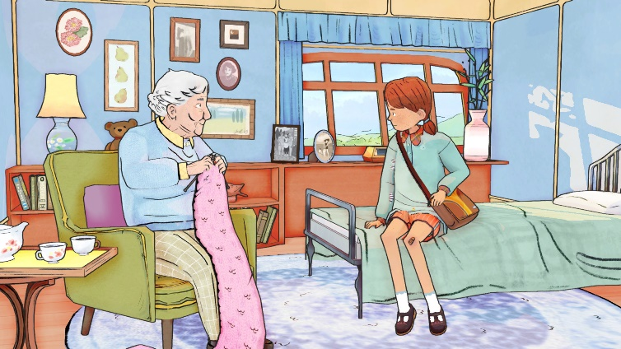
The aesthetics of all these games is generally comprised of a child-like, hand-drawn art style. Although the unique art styles are not a direct parallel of the unique art style of The Cure, they could be a potential future competitor upon release as it could attract the artsy type of audience. The game also seemingly revolves around dialogue choices, as it is an interactive story, to learn information for progression, which is the main mechanic of The Cure. Most of these games also fall into the categories of action adventure driven games. Both the pathless and sable are also open world games, so this type of audience will also be attracted to our game concept.

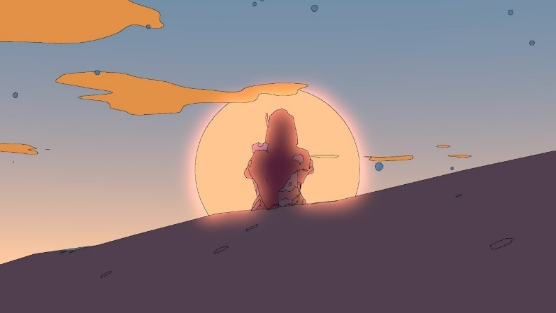

Aside from this, the indie games which are seemingly being released around this time frame are puzzle games. Although The Cure is not specifically a puzzle game, there are some elements in which would appeal to this market, and therefore this can be marketed to people who play these types of games. For example, the player must work out the correct dialogue/information to provide in order to succeed in gaining collectables. However, these games are not direct competitors to The Cure.
There are also several external factors which could indirectly affect the release of our game that do not necessarily have anything to do with the game development industry. One of which is the occurrence of Brexit. As we are intending to market to students, which are majorly English speakers, Brexit could lead to our customers wanting to be careful with money, due to the uncertainties which commonly come along with events/changes like these.
Due to all of the factors which create the environment in which The Cure is released in, we will need to keep up to date on the marketing strategy we follow. This will include increases/decreases in price, with the assumption that it will be sold at a cheap enough price, without underpaying the development team. It will also involve marketing/advertising the game to our audiences to appear a certain way/fit into a specific game genre. We will also need to be wary of how well our competitors are doing sales-wise and how they are marketing their game. To track steam sales of our competitors, there are several online tools which can be used such as https://steamdb.info/sales/.

Inspirations
Like many other games, The Cure’s mechanics take some inspiration from previously created games. An example of one of these mechanics is the time mechanic within the game. This was inspired by the time mechanic seen in The Elder Scrolls V: Skyrim (i.e. Each game day passes in 1 hour and 12 minutes, player can only sleep if beside a bed etc.) We have taken inspiration from this time system because in our opinion, the day does not seem too short or too long. If the day was too short, the feature of not being able to speak to certain NPCs in certain times of the day could allow players to simply wait for a few minutes to overcome this, in turn making the game unrealistic and too fast paced. On the other hand, making one game day any longer than an hour and a half might be bothersome whenever trying to talk to an NPC that is not currently available because it may leave the player with nothing else to do while they wait, which could make the game boring. Finding a balance between the day being overly short and long was therefore an extremely important aspect in developing the game concept, which lead to research of other game’s time systems and the decision that Skyrim’s was the most effective.
We also wanted to add the same realism of the environment changing throughout the day, for example, during the day, shops and other public places can be visited, during nightfall, they cannot. The environment also changes aesthetically, representing a day’s cycle.
Another inspiration taken when designing the game was the element of Mass Effect in which the ending the player receives relies on how well the player did throughout the game, as opposed to being based on 1 main decision. Of course, with such a small team and time frame to complete the game, we could never compete with having a range of 8 endings, like Mass Effect, but instead we decided to have 3 that would rely on the amount of “Good-Will” points the player receives during gameplay. The system that the Mass Effect games uses relies on their own system of “Effective Military Strength”, along with various other aspects. There would be a range of both good endings and bad endings which would ultimately lead the player to replay the game. With The Cure, we wanted to implement a similar aspect of replayability.
There are also several inspirations we looked to whenever developing the overall aesthetics and art style of the game. These, in essence, were very much similar, but there were several elements from each style which we have taken inspiration from, and we intend on combining them to create our own individual art style. The main games which we have taken initial inspiration from are Okami HD and Aragami. These games are comprised of a rather simplistic, cell shaded aesthetic which appears to be completely hand-drawn. It would draw in many audiences that are of the artistic type and appreciate the aesthetics of games, rather than the actual overall gameplay aspects. Therefore, it opens up many marketing opportunities.

References
https://www.polygon.com/2019/11/28/20977711/indie-games-2020-day-of-the-devs
https://www.gamingscan.com/best-upcoming-indie-games/
https://uk.ign.com/wikis/mass-effect-3/Endings

